TASK 1: Repository Setup
Goal: Initialize Git and create first commit
Steps:
- Create a folder named git-assignment-yourfullname
- Navigate into the folder
- Initialize Git repository

4. Create a file named index.txt
5. Check repository status
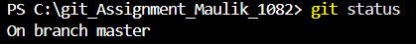
6. Stage the file

7. Commit with message:
Initial project setup
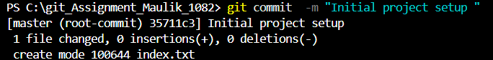

TASK 2: Branch Creation & Work
Goal: Work independently in a branch
Steps:
- Create a branch named feature-header
2. Switch to feature-header
3. Create a file named header.txt
4. Stage the file
5. Commit with message:
Added header section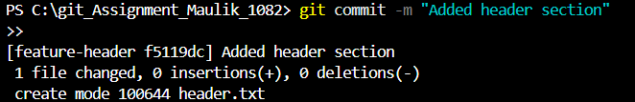

TASK 3: Branch Switching Observation
Goal: Observe branch isolation
Steps:
- Switch back to master
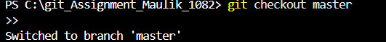
- List files and observe
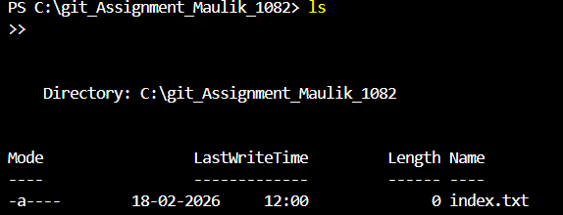
- Switch again to feature-header
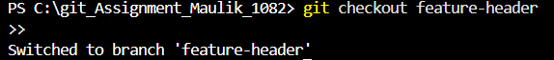

4. List files and observe
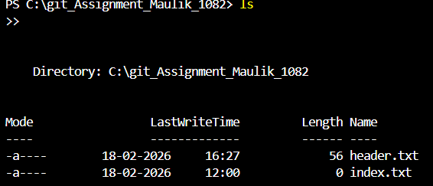
TASK 4: Undo a Mistake
Goal: Safely undo file changes
Steps:

- In feature-header, modify index.txt
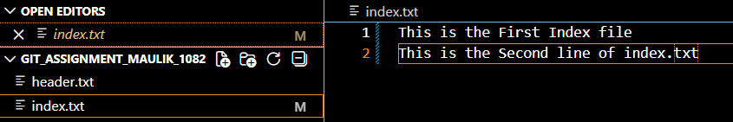
- Check repository status
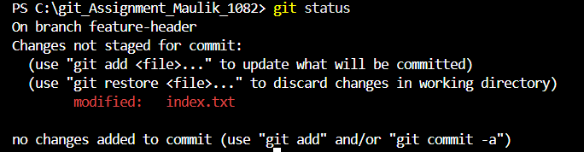
- Undo the change using Git

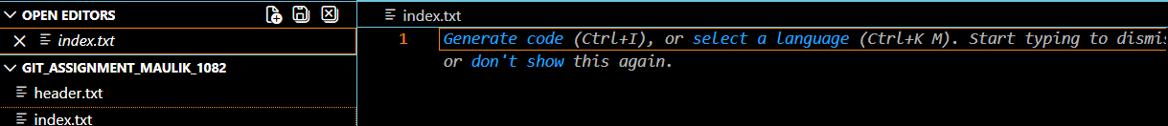
- Verify status again
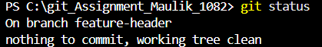

TASK 5: Merge Feature Branch
Goal: Combine work into master
Steps:
- Switch to master
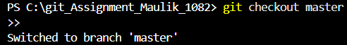
- Merge feature-header
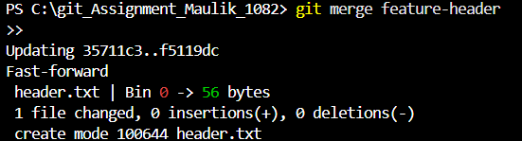
- Verify merged files
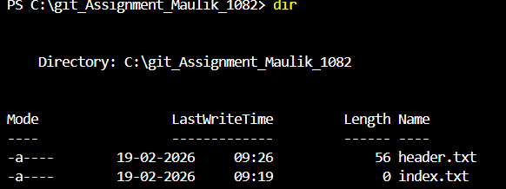
4. Check commit history
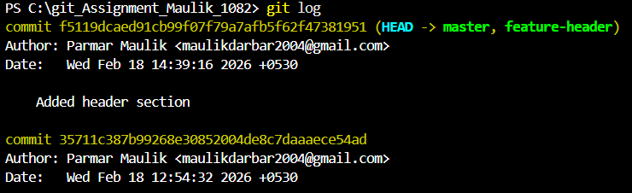
TASK 6: Checkout a Commit (Detached HEAD)
Goal: Understand commit-level navigation
Steps:
- View commit history

- Checkout any older commit

- Check current branch status
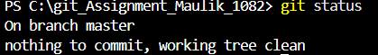

4. Switch back safely to master
